

BASIC MACHINE TRAINING GUIDE
Table of Contents

General Machine Shop Rules and Training Courses 2
Safety 5
Machine and Equipment Care 6
Precision Measurement Equipment 7
Milling 8
I. Machine Specific Setup 8
II. Machining Operations 10
III. Machining Considerations 10
IV. Post machining 13
Lathe 14
I. Machine Specific Setup 14
II. Machining Operations 15
III. Machining Considerations 15
IV. Post Machining 16
Saws 17
I. Machine Specific Setup 17
II. Machining Troubleshooting 18
Hot Shop 20

General Machine Shop Rules and Training Courses

- General Machine Shop Rules
  - Follow all safety guidelines (see Safety section below)
  - If leaving part in machine, leave name, cell number, and time of return
    - Time of return may not exceed 2 hours without Advanced Machinist’s permission
    - Part may be removed at Advanced Machinist’s discretion
  - Must leave shop cleaner than you found it
    - Absolutely no chips left behind (floor or machine)
    - Chip residue wiped off of machines with Simple Green
    - Coolant wiped up from floor and machine, if used
    - Tools cleaned and put in proper place
  - No machine shop tools leave machine shop
    - Includes drill bits, taps/dies, and measuring devices
  - Metal stock
    - Store only that which is actually useful within 1 year’s time
    - Label stock with proper grade
    - Keep stock organized
  - Fixtures
    - Store on fixtures shelf – sorted by team
    - If fixtures are useless or outdated, dispose
  - Shop environment
    - Keyed interior doors are egress only – includes visitors and tours
    - Safety glasses must be worn by everyone if work is being performed
    - Stay inside yellow lines without proper PPE (safety glasses must still be worn)
    - Keep showers/eye wash stations and fire extinguishers clear
    - Keep aisles clear – must be able to egress shop easily
  - Categories of machinists
    - Newbie: Must have Advanced Machinist in machine shop at all times
    - Basic: Has successfully completed Newbie training – must have Advanced Machinist in machine shop
    - Advanced: Senior machinist – has highest level of authority in machine shop and must be present for any machining to take place. Will instruct on good safety practices and proper machining technique
  - Setup Check
    - A setup check (see Safety section below) must be performed before any machine is operated
    - Authorization for use
      - Newbie: Must have Advanced Machinist check off
      - Basic Machinist: Must have Advanced Machinist check off
      - Advanced Machinist: Can self-check
  - Approved Machinist Notebook
    - Includes training docs

- Training Courses
  - Basic Machine training
    - Attend class lectures and pass written exam
    - Team captain nominates for continued training
    - Paired with Advanced Machinist who will give machine demonstrations, general instruction, and observe student use on lathe, mill, and saw
    - Advanced Machinist will sign off on newbie after competency with machine and mill and lathe part checked for proper tolerances
  - Welding training
    - Receive training from an Advanced Welder
    - Must demonstrate proper welding technique by presenting 10 samples of various types of welds to Advanced Welder
    - Advanced Welder signs off on newbie

Safety

- Setup Check – to be administered by Advanced Machinist
  - Safety glasses
  - Proper attire – long pants, covered toe shoes, sleeves above elbow, no jewelry, etc.
  - Hair tied back in bun – if applicable, hats turned backwards
  - Work and tool mounted securely
  - Everything clear of tool through range of cut
  - Improper PPE or people not training must stay behind yellow lines
  - Correct speed calculated and acceptable depth of cut (see Newbie guide)
  - Machining plan – Describe steps on how you plan to make your part
- Potential Hazards
  - Cuts
    - Sharp chips
    - Chips falling into shoes
    - Machine or tool breakage
    - Burrs on work piece
  - Projectiles
    - Flying chips/misuse of air nozzle
    - Flying chuck wrench – keep hand on tool at all times until removed
    - Tool breakage
    - Poorly clamped part
  - Entrainment into machine
    - Improper clothing
      - Long sleeves
      - Gloves
      - No dangly things, including jewelry
    - Hair not tied back in bun - long pony tail not acceptable
    - Bystanders not following proper safety precautions
  - Lack of aid
    - Must have buddy in machine shop
    - If no buddy, no machining
  - Poisoning
    - Infected cuts from bacteria in stagnant water due to lack of Cool Mist
    - Inhaling fumes from tap magic
  - Fire
    - Improper cutting operation which creates sparks
    - Hot material placed on flammable surface (i.e. paper)
    - Improper cutting of magnesium
      - Use big yellow fire extinguisher if fire erupts
  - Crushing
    - Improper lifting of heavy objects – get assistance from others
    - Plan ahead and check foot path for obstructions
  - Falls
    - Slippery floors due to coolant
    - Slippery floors due to abundance of chips
    - Tripping over objects – plan steps in advance

Machine and Equipment Care

- Measuring Equipment (Calipers, Dial Indicators, Micrometers, etc)
  - General Care
    - High precision instruments must be handled carefully
    - No sudden shocks – no dropping, beating, etc
    - Avoid exposure to liquids (especially digital calipers), heat, dirt, etc.
    - Improper use can cause them to lose their tolerances and make them useless
  - Shop usage
    - Equipment designated for machine shop must not leave the room
    - Always store in designated location
- Machine Cleaning Procedure
  - Applies to all machines
  - To be performed upon completion of work
    - All chips removed from machine and floor
    - Chip residue wiped off of all surfaces on machine with Simple Green
      - Do not use Simple Green on greased surfaces – just wipe off with clean rag
    - If coolant used, wiped up completely from machine and floor
    - All tools cleaned and put back in designated location
- Milling Machines
  - Use automatic oilers to lube ways on a weekly basis – Adv Machinists perform
  - Cup oilers will be oiled by Support Engineer
  - Use chip guards
  - Do not over tighten drawbar
  - Do not leave wrench on drawbar – ever
  - Do not adjust speed unless machine is turned on
  - Make sure spindle brake is not stuck in the engaged position
  - Do not allow tool to cut vise
- Lathes
  - Oil Levels
    - Always check sight glasses before use
    - Low oil will cause damage to machine
    - Fill up if low using Medium Way Oil found in prep room cabinet
  - Use chip guards
  - Do not leave chuck wrench on chuck – ever
  - Always make sure tool and holder are clear of chuck before operation
  - Thoroughly clean insert holders when changing inserts
    - Can cause all sorts of issues (poor surface finish, tool breakage, etc)
    - Use anti-seize on threads to prevent sticking
    - Do not over tighten insert screws
- Saws
  - Clear chips after every use – can cause rust
  - Make sure guides are adjusted properly – height and blade separation
  - Occasionally check rubber on large pulleys for chips to remove
  - If changing gears, always do manually and make sure gear is engaged before operation

Precision Measurement Equipment

- Calipers
  - Used for general purpose measurement
  - Best for quick measurement of small parts
  - Measures: inside diameter, outside diameter, thickness, depth
  - Can calibrate using gauge block
- Dial Indicators
  - Some common usages
    - Dial in part on lathe
    - Tram mill and vise
    - Position part relative to head
  - Measures: linear distance
- Micrometers
  - Excellent for measuring diameters and large openings
  - Generally more accurate than calipers
  - Some have greater range of measure than calipers
  - Use gauge block to calibrate
  - Measures (our set): outside diameter, thickness
- Gauge Blocks
  - Used for measuring z-axis
  - Can calibrate calipers and micrometers
  - Use dab of oil on surfaces to increase precision
  - Used to get accurate distances
- Transfer Gauges
  - Used to measure places other equipment can’t get to
  - Does not read out a measurement, must use caliper/micrometer to obtain measurement
- Vernier Dials on Machines
  - Lathes and mills both have dial gauges in all directions
  - Use them when other instruments aren’t available

Milling

Machine Specific Setup

  - Coordinate system
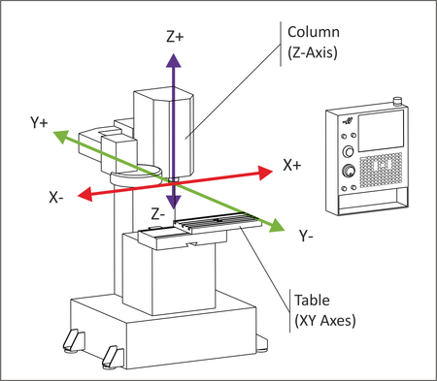
  - Perfect 90° and flat surface cuts
    - Head is trammed perpendicular to table
      - Thoroughly clean table’s surface w/ lubricant
      - Mount dial indicator on spindle
      - Rotate spindle to make head perpendicular to table in X and Y directions
    - Vise is trammed perpendicular to table
      - Thoroughly clean mating surfaces w/ lubricant
      - Mount dial indicator on spindle
      - Run indicator on back face of vise to square up to table
  - Tool selection
    - Ensure it is sharp by looking at the tip of each tooth
    - Size tool to match cutting operation
    - Determine features needed for cut
  - Calculate spindle speed
    - Look up cutting speed for milling in Machinery’s Handbook
    - RPM = 4 x cutting speed (sfm) / diameter of tool (inch)
  - Speed change
    - Can cause damage to machine if done when machine is off
    - Perform slowly
    - Ensure low/high lever is in proper position for RPM desired
  - Part clamping on table
    - Use clamps to keep part from shifting
    - Clean table and part well so they seat well
  - Part clamping in vise
    - Must be tight to keep part from shifting
    - Use parallels to make part level and adjust height
    - Clean vise and part so they seat well
    - Lightly clamp part, use mallet to firmly seat, then fully tighten
    - Plan ahead and do not allow the tool to cut the vise
  - Locate X and Y axes
    - Method 1
      - Load edge finder into machine with collet
      - Set speed to 1000 – 1400 RPMs
      - Set edge finder height and slowly move X axis until finder “kicks” out.
      - Subtract half the width of finder and zero axis.
      - Repeat for Y axis
    - Method 2
      - Take cut with one axis (lock other axis in place)
      - Measure part (do not remove part from vise)
      - Subtract that figure from desired measurement
      - Use DRO to obtain desired measurement
  - Locate Z axis
    - Using feeler gauge
      - Clamp part and insert tool onto machine
      - With machine off, get part close to bottom of tool
      - Slide gauge between part and tool while raising part until gauge slides with minimal friction (Caution: raising too much may chip tool)
      - Move part up gauge thickness
    - Gauge block
      - Clamp part and insert tool onto machine
      - With machine off, get part close to bottom of tool
      - Move gauge block between part and tool while raising part until tool touches gauge block
      - Move part up length of gauge block
  - Depth of Cut (radial and axial)
Note: Numbers to be used as a rule of thumb
    - Face milling (axial cutting)
      - Steel: 0.01” (half aluminum)
Width of Cut = 75% width of tool – reduce DOC if more
      - Aluminum: 0.02” (2x steel)
Width of Cut = 75% width of tool – reduce DOC if more
    - Shoulder/contour milling (radial cutting only)
      - Steel: 0.01” (half aluminum)
Width of Cut = 75% width of tool – reduce DOC if more
      - Aluminum: 0.02” (2x steel)
Width of Cut = 75% width of tool – reduce DOC if more
  - Coolant
    - Steel: When using HSS bits, may want to use to help with tool life
    - Cutting aluminum: not needed
    - Not needed with carbide indexable tools
    - Not an excuse to go faster
  - Feed
    - Always feed part into bit slowly to get a feel for tool
    - Observe chips, if chips too hot to touch, slow feed down
    - No way to accurately set feed rate, so calculation on manual mill means little

Machining Operations

  - Face milling
    - Taking large portions of metal off top of part to get to certain depth
    - Fastest way is to use the “Bearclaw” indexable cutter
      - Speed: 900 RPM, material: aluminum only, DOC: 0.04” max
    - Never engage ~50% of tool due to improper insert loading. 70% ideal, 25% ok
  - Slot milling
    - Uses 100% width of tool
    - Reduce depth of cut by 50%
    - Is the hardest operation a tool will experience
  - Shoulder/contour milling
    - Cutting on outsides of part which engages less of tool
    - Can take larger depth of cut but width of cut is shallow
  - Pocket milling
    - Cutting the inside of the part
      - Not typically a manual milling operation
    - First pass is similar to slot milling
    - If extra passes are required, depth of cut may be slightly increased
      - Take it slow in corners since it will engage more of the tool
  - Drilling
    - Use drill press or drill chuck with integrated taper for mill
    - Find sharp bit
    - Determine hole size and find 2-3 bits to step up to that size(if over ¼”) – larger drill bits don’t cut in the center well
    - For deep holes, peck drill – pick up quill to clear chips every ¼” or so
    - If gets hot, find sharper drill or use some coolant
Note: Drilling does not provide very accurate or round holes – see reaming
  - Reaming
    - Follow procedure for drilling
    - Reduce final size of hole by ~1/32” for small holes (less than ½”)
    - Install reamer into proper collet
    - Reduce spindle speed by at least half

Machining Considerations

  - Surface finish
    - Use sharp tool
    - Take smaller depth of cut (ie, finishing cut)
    - Take larger depth of cut – too small and cutter radius may be too large to cut
    - Increase or decrease speed and feed 10% to see if finish improves
    - Use climb milling
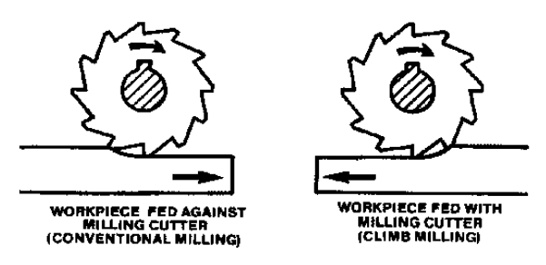
  - Tool life
    - Use proper speeds and feeds
    - Possible use of coolant
    - Proper depth of cut and width of cut
  - Accuracy
    - Do not get in a hurry, take your time
    - Measure twice (with precision tools), cut once
  - Noise reduction
    - Check speed – adjust ±150 RPMs
    - Increase feed rate – tool is possibly rubbing
    - Use sharp bit
  - Part getting too hot
    - Identified by
      - physically feeling chips – catch some chips in hand with caution
      - chip discoloration – only observable with steel – chips turn blue
      - continuous smoke
    - Adjust speed
    - Use slower feed rate
    - Take less depth of cut
    - Use sharper tool
Note: Excessive heat reduces strength of tool and damages it
  - Square stock
    - Clamp round rod in with part in vise
    - Keep rotating part till each surface is machined
  - Small diameter hole (less than ½”)
    - Use DRO and center drill to locate hole
    - Use 2-3 drill bits to increase size to desired diameter
For highest accuracy, undersize hole 1/32” and use reamer for the final cut
  - Large diameter hole (greater than ½”)
    - Follow above procedure and continue increasing drill bit sizes
    - When size exceed drill bit available, use boring head
Note: Don’t be afraid to ask for help to set up properly
  - Cut part to specified height
    - Measure height of part and locate end of tool to top of part
    - Calculate depth of cut
    - Use vernier scale on Z axis to raise table incrementally to desired height
  - Cut part to specified length or width
    - Clamp part such that cut can be performed (ie, hang off end of vise)
    - Use edge finder and DRO to locate both ends (be sure to account for tool diameter if it applies)
    - Make incremental cuts to desired length or width
  - Ridges in surface of part
    - Head not trammed
    - Tool has teeth missing
  - Insert installation - Bearclaw
    - Find correct tool to undo screws – do not strip!
    - Remove old insert and install new one
    - Put anti-seize on threads of screws and do not over tighten

Post machining

  - Deburring
    - Improves accuracy if performing more machining operations
    - Prevents cuts on hands
    - Removes crack inception sites
    - Makes part look finished
  - Tapping
    - Determining hole size
      - Locate tap chart and find thread desired
      - Select drill size according to chart
      - Note percent of thread changes depending on drill size
    - Keep part in machine and accurately locate holes – do NOT turn on machine!
    - Loosely put tap in chuck and start by hand a few threads to line up tap
    - Ensures tap is perpendicular to part
    - Use cutting fluid liberally
  - Clean up
    - Leave machine and shop cleaner than you found it
    - Put all tools back in their proper place
    - Properly label extra stock and put in designated place on shelf
    - Remove all chips with brush – use air nozzle only for hard to reach places
    - Prevents lost tools and promotes safe working environment
    - Clean precise tools make clean precise parts

Lathe

Machine Specific Setup

  - Coordinate system
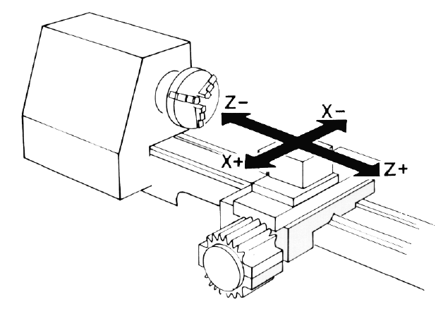
  - Tool selection
    - Determine type of cut (facing, inner/outer diameter, cut off, etc)
    - Select proper tool for cut
      - Boring – use boring tool
      - Facing, turning – WNMG/CNMG insert tool
  - Set tool height
    - Face part and reduce size of nub to nothing - tool is set
    - Put center in tailstock and set tool height
    - Use height adjustment tool (soon to be built)
  - Speed selection
    - Look up cutting speed for turning in Machinery’s Handbook
    - RPM = 4 x cutting speed (sfm) / diameter of tool (inch)
    - Set levers to closest calculated number
  - Clamp part
    - 3 Jaw
      - Use chuck tool to clamp down part – don’t get “super” tight
      - Remove chuck tool before starting machine – tool never leaves hand
      - Part will be between 0- ~0.005” from center
      - If part not perfectly centered, on first pass of tool, working area of part will be perfectly centered
    - 4 Jaw
      - Line up part using dial indicator w/ magnetic base
      - Rotate chuck and use chuck tool to clamp down part
      - Remove chuck tool before starting machine – tool never leaves hand
  - Depth of Cut
Note: Numbers to be used as a rule of thumb
    - Steel: 0.015” (half aluminum)
    - Aluminum: 0.03” (2x steel)
  - Maintenance issues
    - Be sure to check oil level before use
    - Fill up if low using Medium Way Oil found in prep room cabinet
  - Measuring
    - DRO defaults to measure on the diameter (can be set to read on the radius)
    - Vernier dials read on the diameter
  - Coolant
    - Not advised to use coolant with carbide inserts – creates micro cracks in insert
    - Definitely used on drilling and HSS tools
  - Changing inserts
    - Find correct tool to undo screws – do not strip!
    - Use air to blow out any chips in socket
    - Remove old insert and install new one
    - Put anti-seize on threads of screws and do not over tighten

Machining Operations

  - Facing
    - Machine end of part
    - Must use some form of right hand tool cutter
    - Set depth and use X axis feed to face off
  - Turning - Outer diameter
    - Machine outside surface of part
    - Can use any form of tool holder
  - Drilling
    - Puts holes through part
    - Install drill chuck in tailstock – use coolant
    - Peck drill (move drill bit in and out of hole every ~¼” to clear chips)
    - Gradually increase size of drill bit (if over ¼”) until desired size is reached
    - Use boring tool if hole needs to be bigger than available drill bit size
  - Boring - Inner diameter
    - Makes part that requires an inner diameter
    - Use boring tool that corresponds to the size hole in the part
    - Only stick bar out as far as absolutely necessary – more overhang = less rigid
    - Max overhang – HSS: 4x diameter of bar, Carbide: 6x diameter of bar
  - Parting - Cut off
    - Cut off part from stock clamped in chuck
    - Must reduce speed by 50%
    - May need to take a multiple cuts as tool has tendency to wander
    - Adjust so insert overhang is minimized

Machining Considerations

  - Surface finish
    - Adjust speed ±150 RPMs
    - Adjust tool to centerline of part
    - Make sure tool is sharp
    - Use proper tool for the job (see Tool selection above)
    - Take larger depth of cut – too small and insert radius may be too large to cut
    - Leave a few thousandths and sand part down for best finish
  - Accuracy
    - Use DRO with caution. Always stop and measure often
    - Leave plenty of time to stop and measure
  - Noise reduction
    - Check speed – adjust ±150 RPMs
    - Increase feed rate – tool is possibly rubbing
    - Use sharp bit
  - Part getting too hot
    - Use slower feed rate
    - Tool is dull
    - Too large a depth of cut
Note: Excessive heat reduces strength of tool and damages it
  - Chip clearing
    - Do NOT remove chips while machine is turning. Stop machine first then remove
    - Do NOT use gloves to clear chips while machine is running. This is worse than above. Gloves ok after machine is stopped

Post Machining

  - Deburring
    - Improves accuracy if performing more machining operations
    - Prevents cuts on hands
    - Removes crack inception sites
    - Makes part look finished
  - Tapping
    - Keep part in machine and accurately locate holes – do NOT turn on machine!
    - Put chuck in tailstock
    - Loosely put tap in chuck and rotate head by hand a few threads to line up tap
    - Ensures tap is perpendicular to part
    - Use cutting fluid liberally
  - Clean up
    - Leave machine and shop cleaner than you found it
    - Put all tools back in their proper place
    - Properly label extra stock and put in designated place on shelf
    - Remove all chips with brush – use air nozzle only for hard to reach places
    - Prevents lost tools and promotes safe working environment
    - Clean precise tools make clean precise parts

Saws

Machine Specific Setup

  - Blade
    - Three teeth contact part at all times – more the better
      - Aluminum uses larger pitch to aid in chip clearing
      - Steel uses smaller pitch to engage more teeth in the cut
    - Valleys in blade remove chips
    - Adjust blade guide height to fit material thickness
    - Blade types
      - Carbon steel – Good for soft metals, cheaper
      - Bimetal – HSS cutting teeth bonded to carbon steel backing. Good for harder steels and improves blade life
      - Carbide blade – Ideal for hardened steel, expensive
    - Variable pitch blade reduces vibration and increases blade life and finish
      - Horizontal saw: 5-8 TPI (teeth per inch) good for ½” or larger material
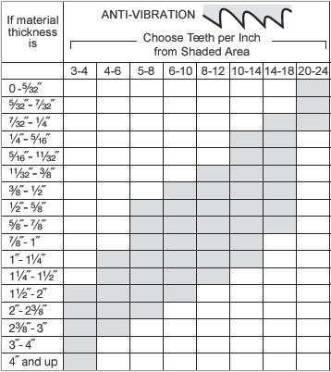
      - Vertical saw: 10-14 TPI good for ¼” and below
  - Speed
    - Vertical Saw
      - See chart on side of machine
      - Determine type of material used and thickness
      - Adjust dial to proper speed indicated
    - Horizontal Saw
      - Speed adjusted by belts. Typically good for general purpose.

  - Part holding – Vertical saw
    - Do not use hands with small parts
    - Use V-type part holder – should be located close to saw
    - Use wood to push through
    - Use small vise to hold round material – do NOT allow round stock to rotate, it will destroy blade
  - Feed
    - Vertical Saw
      - See chart on machine and use specified feed
      - Feeds listed in rabbit, donkey, and elephant. For rabbit, do NOT push hard
      - Use part holder to prevent injury
    - Horizontal Saw
      - Feed automatic
      - For thin wall tubing – slow feed manually or don’t use
      - Can adjust weight to apply more force on cut

Machining Troubleshooting

  - Hot material
    - Feeding too fast
    - Dull blade
    - Improper speed
  - Poor surface finish
    - Feeding too fast
    - Dull blade
    - Improper speed
    - Blade guides adjusted improperly
  - Poor blade cutting
    - Dull blade
    - Speed too high
    - Blade guides adjusted improperly
    - Teeth pointed wrong direction/blade installed backwards
  - Saw not cutting in straight line
    - Blade guide height too high
    - Blade guides not set properly – reduce separation
    - Too high feed rate
    - Not holding part rigid enough
  - High force required to cut – see Poor blade cutting
  - Loud noises
    - Feeding too fast
    - Dull blade
    - Improper speed
  - Teeth stripping
    - Feed pressure too high
    - Tooth stuck in cut
    - Part spinning
    - Speed too low
  - Chip test – see following chart
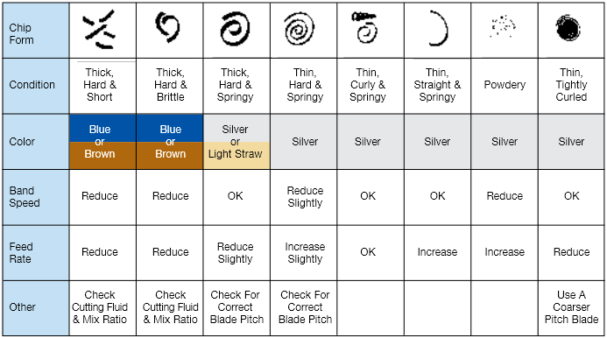

Hot Shop

- Safety
  - Follow machine shop safety rules
  - Everyone must have safety glasses if work is occurring
  - No flammable material allowed in area
  - Before any hot operation (sparks, etc) check for accidental placement of flammable material near area
  - Be extra cautious of sharp objects (burs on metal, sharp edges, etc). Always place materials in place someone cannot accidentally walk past and cut themselves
  - Make sure all gas bottles are secured
- Grinders
  - Bench grinders
    - Ensure guards are properly adjusted
    - Steady part when grinding – if it slips, can cut skin
    - Use pliers/vise grips to hold part
  - Side grinder/dremel/air grinder
    - Determine path of sparks before starting and make sure area is clear
    - Ensure part is clamped securely
- Chop saw
  - Use ear protection in addition to eye protection
  - Announce to shop beginning of operation so everyone is prepared for the loud sound
  - Do not put excessive pressure on handle when cutting – can prematurely wear blade
- Welder
  - Do not touch – must take and pass welding training class
  - Do not look at pretty blue light when someone is welding or if you are forced to hold something in place

