Brandi P. Smith
February 2, 2007
Comp 7970
Assignment 3
The Game of Donkey Kong
The game of Donkey Kong was created in 1981 by game designer Shigeru Miyamoto who was working at Nintendo in Japan. The president of the company, Hiroshi Yamauchi assigned Miyamoto the project of making improvements to the game of Radar Scope because Nintendo needed a way to get in good with the North America market because they were not having success with the arcade game Radar Scope at the time. So, Miyamoto took on the project without having much to work with. He decided to design a new game from scratch. He used Popeye the sailor man because this character was his inspiration. Miyamoto wanted to create a game that involved Popeye attempting to rescue Olive Oil, his girlfriend, from Pluto (the British bully). Nintendo was not able to receive a license to make a game based upon Popeye. So they came up with the idea of making new characters to replace the characters of Popeye. Miyamoto changed the characters; he decided to make Olive Oil to a character named Pauline, Popeye to a character Jumpman and Bluto to an Ape, who name was Monkey Kong. The Jumpman’s name later was changed to Mario after Nintendo’s warehouse landlord, Mario Segali. The Ape’s name Monkey Kong later changed into Donkey Kong after someone mistakenly called him Donkey instead of Monkey. Miyamoto decided to keep the name Donkey Kong because he found out that the term Donkey meant stupid.

Story Line
The game consists of a damsel-in-distress scene. Donkey Kong has the role of a villain, where he kidnaps the Mario’s girlfriend, Pauline, and holds her hostage. The player has to take the role of the Mario and rescue his girlfriend. When the game begins Donkey Kong climbs to the very top area of the construction beams and begins roll barrels. The player has to attempt to rescue Pauline by moving up to the top by climbing ladders. But some ladders appear to be broken and also there are obstacles of fire and rolling barrels that the player must avoid by jumping over them to continue with life. They have to use their control set to jump and move back and forth and up and down ladders. Also, the player has the ability to destroy these objects with a hammer that has power and moves fast. The hammer will appear attached to the construction beam and the player must grab it and use it to eliminate such obstacles. When the player reaches the end of the stage there is a cut scene (a sequence in the video game that advances the plot). When Mario reaches the final stage and completes it, the two lovers, Mario and Pauline are together again.
The Graphics
The animations within the game allow Mario to have a large mustache, red overalls, a blue shirt, and a red hat. There were white gloves added to his character to make the movement of his arms visible. Pauline was designed with a pink dress and long hair. The background was designed with construction beams that include climbing ladders, hammers, umbrellas, purses, and balls all in different stages of the game. Example pictures are provided below.

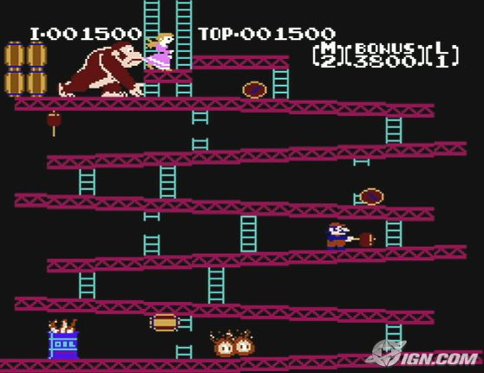
Figure 1: Mario with the power hammer in Donkey Kong (2)

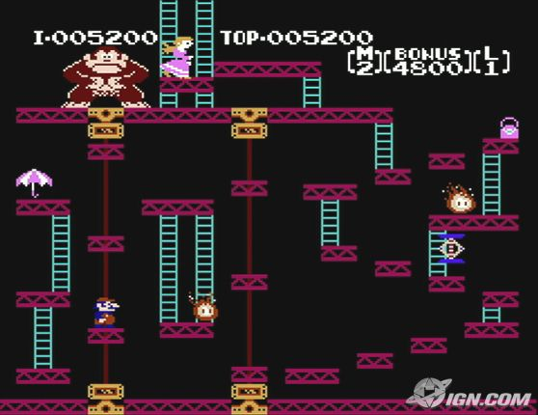
Figure 2: Donkey Kong at a higher level with the items of an umbrella and purse on the scene (2)
The Genre
Donkey Kong created a new genre called the platformer genre. The platform genre consists of allowing a character to have the actions of jumping. The characteristics of this jumping consist of the player having the ability to jump to and fro from different platforms as part of the game play. Such games will include a jump button on the controller.
Other games that are in the platform genre include Super Mario Brothers, Dragon Buster, and Pitfall. Super Mario Bros. was different from Donkey Kong because it has smooth scrolling levels. Super Mario Bros. also has additional sub-genres of hop and bop, which allows the enemies to be defeated with the player jumping on their head. This was different from Donkey Kong because the game of Donkey Kong did not have such a sub-genre of hop and bop and also because the levels stay in one position, they do not have the capability of scrolling. Dragon Buster was a vertical scrolling game that involved a character rescuing his princess. This game is different from the game of Donkey Kong because it has the vertical scrolling and also because it has a level of vitality, and have the ability to swing swords. Pitfall was a game that was created by Activision that has a character to go through a maze-like jungle to get treasures. The player has to jump and avoid obstacles such as tar pits, quicksand, fire, rattlesnakes, and walls. This game is different from Donkey Kong because it allows the character of the game to climb on vines and swing across obstacles, whereas, Donkey Kong only allows the ability to climb up and down ladders and jump over obstacles.

The Audience
What gives people the sensation to play the game of Donkey Kong? Well in the beginning people were interested in playing Donkey Kong because it was the first game that actually had a story line to it. It was a new idea, something that no one had succeeded in doing. It also gave the player the capability of controlling their character in a different manner, by allowing them to jump over obstacles. People found the game to be fun because it showed different scenery and allowed the players to be more interactive with the jump moves of the characters. Also, it was more fun because the players had the ability to play it for a particular purpose of giving the characters a story to interact with the game, which was to defeat the obstacles to rescue Mario’s love from that big Ape.
The Effect of the Animations
The animations gave the game more excitement. With the characters having bright colors such as red and pink, allowed the game to be more vibrant. Also having the characters of Mario, Donkey Kong and the Princess to have their on specific and different actions gave more variety of the animations of the characters. Considering that the game of Donkey Kong was developed in 1981 the game did not include an excessive use of technology because today games involving technology have become more advance. The playability of the game was not hard due to the lack of such technology. The game had simple functions that allowed the playability to be easy to learn.
Teaching a Classmate
Donkey Kong has the ability to be played on the Nintendo with a controller or on a PC with a keyboard. I taught my classmate the game on the PC at the website www.virtualnes.com. To play this game on the PC you do not need a controller, but you do need your keyboard and mouse. The player has the ability to control the character of Mario with the keyboard. To control Mario’s actions you must use the up, down, left, and right keys to move him forward, backward, or up and down the ladder. To make Mario jump you must use the X key on the keyboard. A picture of the environment of playing the game on the PC is provided below.

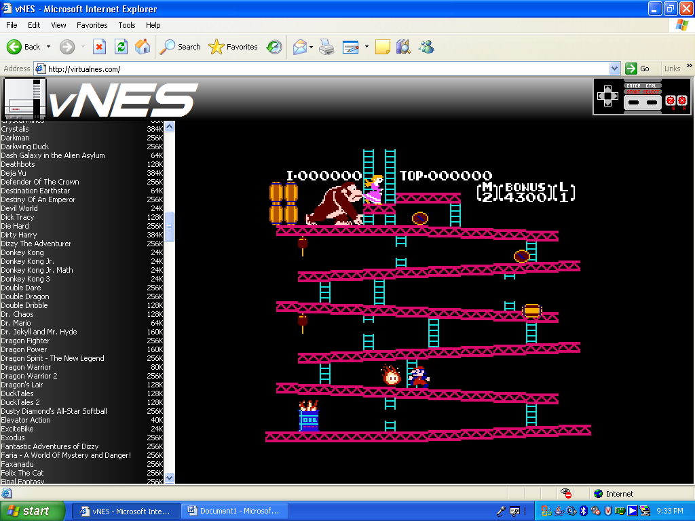
Figure 3: The Donkey Kong game on www.virtualnes.com

This was the first time that my peer played the game of Donkey Kong. He found the game to be relaxing and fun. He enjoyed learning how to control the game with the keyboard and he enjoyed learning the objective of the game. It took him about five games to get good enough at controlling the character to have fun with the game. When he finally got familiar with controlling the character and also with the keyboard functions he began enjoying the goal of trying to rescue the princess. He found that the ability to control the character was easy to learn. He did not agree much with the other optional keys like the Z key that were not used to control character. He felt that it was there just to confuse the player. He also found it interesting of how the barrel had the ability to roll in a certain direction of the player based upon the player’s position in the game. In conclusion, my peer enjoyed playing the game of Donkey Kong because he felt that it was a fun and relaxing activity.
With the results of my peer learning the game, it turned out that not only was the game of Donkey Kong easy to learn and exciting to play in the past years, it also continues to be an easy and exciting game for today and tomorrow.

Reference Websites
1. http://en.wikipedia.org/wiki/Platform_game
2. http://wii.ign.com/articles/748/748752p1.html
3. http://en.wikipedia.org/wiki/Donkey_Kong_(video_game)
4. http://www.miyamotoshrine.com/kong/hist/dk.shtml

