Technical Writing Information Sheets
Department of Chemical Engineering
Auburn University, AL 36849
Format for Figures, Graphs and Charts

Figures (Illustrations, Graphs and Charts)
Just as a photograph is worth 10,000 words, the use of graphical tools can play a major role in highlighting and clarifying results and data. Appropriate, well-drawn graphical tools (visual aids) can substantially increase comprehension of the text and can convey trends, comparisons, and relationships more clearly than text alone.
- Do not use a numerical table to show a trend.
- Do not use a graph to communicate a numerical value.
Types of Graphical Presentations

- Illustrations: Use to illustrate an apparatus or to represent a concept or the relationship between concepts. See examples below.

- Graphs and Charts: Use to illustrate trends in data. Use to make comparisons or contrasts between 2 or more sets of data. See examples below.

Types of Graphs and Charts:

A graph can present the same statistical data as a table. You must determine whether a bar, pie, line, or scatter graph is best.

- Use a line graph to depict trends or relationships. In a trend, the same data change over time. The population figures for one city at different points in time is an example of a trend. A relationship shows the interaction of two variables, for example, percentage of pollutant to size of a filter.

- Use a scatter chart to show a correlation. For example, show the correlation between experimental and theoretical data.

- Use a bar graph to compare discrete items. For example, the population of three different cities at one point in time can be shown using a bar graph. Research shows that bar graphs are the easiest for less knowledgeable readers to grasp.

- Use a pie chart to represent discrete values as parts of a whole. If you want to illustrate educational level to average annual income, use a pie chart

Important Note: When using Microsoft Excel ® note that the chart type called “line chart” does not produce “line charts” as defined above. In order to produce a standard graph demonstrating a trend or relationship use the Excel “XY (Scatter)” chart type. Excel ® line charts are only used to plot data where there a “category” as the independent axis, for example, day of the week, list of suppliers of a part, classification of weather type, etc. When you have numerical data representing the x-axis, the appropriate chart type is “XY (Scatter)”.

General Guidelines for Figures (Illustrations, Graphs, and Charts)

- Identify all visual aids as tables or figures. Anything that is not a table is a figure—no matter what form it takes. Figures include: illustrations, graphs, photographs, maps, etc.

- Do not use the words "chart," "exhibit," "graph," or "photo," when naming a specific figure.

- Place table numbers and titles directly above tables. (See separate guide for Format of Tables)

- Place figure numbers and legends (captions) directly below figures.

- Use Arabic numbers (Figure 1, Figure 2, etc.) to label figures. Also, use Arabic numbers (Table 1, Table 2, etc.) to number tables. Number figures and tables consecutively throughout the text and within appendices. (Each sequence is independent).

- When you refer “generically” to a figure or table, it is not capitalized. For example, “One can see significant experimental “noise” in the data in this figure.”

- Keep all illustrations for the same manuscript consistent in font size and face, symbol size, and line weight. Note: This does not imply that the font used in illustrations has to be the same as the report text.

- If an illustration or figure has some bearing on a conclusion to be drawn, an explanation of the graphic should be given in the text above or prior to showing the graphic.

- Refer to each visual aid in the text with “Fig. 1” “Eq. 1” or “Table 1.” (Please note that the words figure and equation are abbreviated in the text, but table is not.) When the word “Figure” or “Equation” begins a sentence it is written out in full.

- As the writer, you should always provide the reader with information (directions) for understanding and interpreting the data represented in a figure or graph. Conclusions should be drawn about the graphic. Do not expect your reader to look at the graphic and draw the same conclusions that you did.

General Comments about Figures
- A figure is any graphic that is not a table. Figures include graphs, drawings, diagrams, photographs, maps etc. Every figure must be discussed in the text.

- Every figure must have a figure number and a legend (caption). Tables and figures are numbered separately. Therefore, Table 5 could appear in a document after Figure 20. In a lengthy document with chapters or numbered sections, use hyphenated numbers for your figures, i.e. Fig. 3-2. The first number indicates the chapter or section, and the second number indicates the number of the figure within that chapter or section.

- The wording of the legend (caption) must be in agreement with the wording of the text, that is, if you refer to the figure by its caption, you must fully cite it. The title of a figure should resemble a sentence, that is, the first letter is capitalized and the remaining letters are lower case. There is a “period” at the end of the title.

- Never add new ideas or new interpretations to a figure via its legend (caption). For example, citing the temperature that the data was collected at in the legend without this information being cited in the text. The legend should be understandable without reference to the text.

- When figures are less important to your explanation, they may be located in an Appendix. In this case, they are numbered as Figure A-1, Figure A-2, etc.

- Use similar wording for captions of related figures, that is, be consistent rather than confusing.

- Keys to symbols can appear in the legend or in the figure. They should be placed in such a fashion as to avoid giving a cluttered appearance.

- Standard abbreviations are permissible when adding labels, legends, and captions (as long as the reader will be familiar with them).

- Do not refer to figures by page number. Referring to their figure number is sufficient to locate the information. For example, don’t write, “Figure 5 (see page 15)…”.

- List data sources or references for your figures in the legend of your figure (i.e., Source: Bureau of the Census, 1990).

Specific Information about Graphs

- A line graph shows the relationship of two variables or more variables by a line connecting points inside an x (horizontal) and a y (vertical) axis. The “independent variable” is always displayed on the x-axis and the dependent variable(s) is/are displayed on the y-axis. These graphs usually show trends over time, such as profits or losses from year to year.

- The main goal of employing a graph is to allow the reader to see important relationships between independent and dependent variables. Often the reader will be “using the graph” to establish the value of a parameter at a point of interest. For that reason, effective graphs are plotted in a size and fashion to make reading data values as easy and accurate as possible.

- Often data should be plotted on “transformed” axes in order to “straighten” (linearize) the curvature of the data as much as possible to make possible reading the graph accurately. Typical transformations are exponential or logarithmic axes although many other types of transformations are used.

- If more than one line or set of data appears in the graph, use a legend to explain what each represents. If you use several lines, make them visually distinct. For example, use a dotted line and a continuous line, or use different colors. Remember, if your graph is to be printed using conventional copying technology, colors reproduce poorly and can cause confusion.

- Combining curves that have the same set of axes saves time and space, but do not put more than four or five curves in one set of axes. Leave sufficient space between curves; they should not overlap so much that these symbols are indistinguishable.

- Graphs are intended to convey engineering information in an effective fashion. Your graphs should be clearly legible and of a size sufficient to convey the data accurately. On the other hand, most graphs do not need to fill an entire page. In the case of full size page landscape orientation graphs, make sure the top of the graph is in the same location as the left edge of the report when viewed in portrait orientation.
- Plots of experimental data should use symbols to represent the individual data points.

- The symbols should not be joined with a line. Plots of a function or best-fit curve to data points should be represented with lines without any symbol

- Legends should be placed within the field of the axes of the graph.

- The axes on plots must each have a title with the units used enclosed in parentheses. Units may be omitted for non-dimensional quantities.

- Plots should be scaled so that the final digits in the numerical labels on the axes increment by one, two, five, or ten.

- The labels’ size should be reasonable compared to the size of the plot.

- The number of numerical labels should be reasonable for the plot. If they are too crowded the graph is difficult to read.

- The scales should also be chosen so that the data span a reasonable fraction of the axis length.

- Scale labels should be along the edges of the graph area and not through the middle of the graph area.

- Many times it is useful to put multiple data sets on the same graph when making comparisons rather than making multiple graphs.

- The use of E for exponentiation in graphs (e.g., 1.5 E –5) is undesirable but often necessary because the plotting software does not permit the more desirable use of superscripts (e.g., 1.5 x 10⁻⁵).

- Unless it has a clear purpose, the use of color should be avoided because it will generally not be reproduced in photocopying.

- Figures should fall within the same margins as the text.

- Put a symbol at each data point or state (in the text) the reason you did not do so.

- In this lab, do not connect individual data points with straight lines. Draw at least squares fit instead, with confidence intervals, if required.

- The algebraic equation of the fit must appear on the graph.

- Show different sets of data by using different plotting symbols. Define these symbols in the legend or on the graph, but not in the text.

- Do not use plotting symbols to show the points at which you evaluated the function to plot it. These points mean nothing.

- Show different functions by using different line types. Define these line types in the legend or on the graph, but not in the text.

Examples of Illustrations

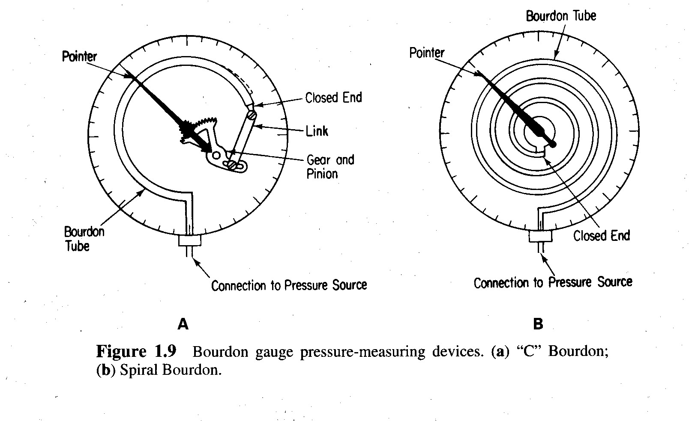

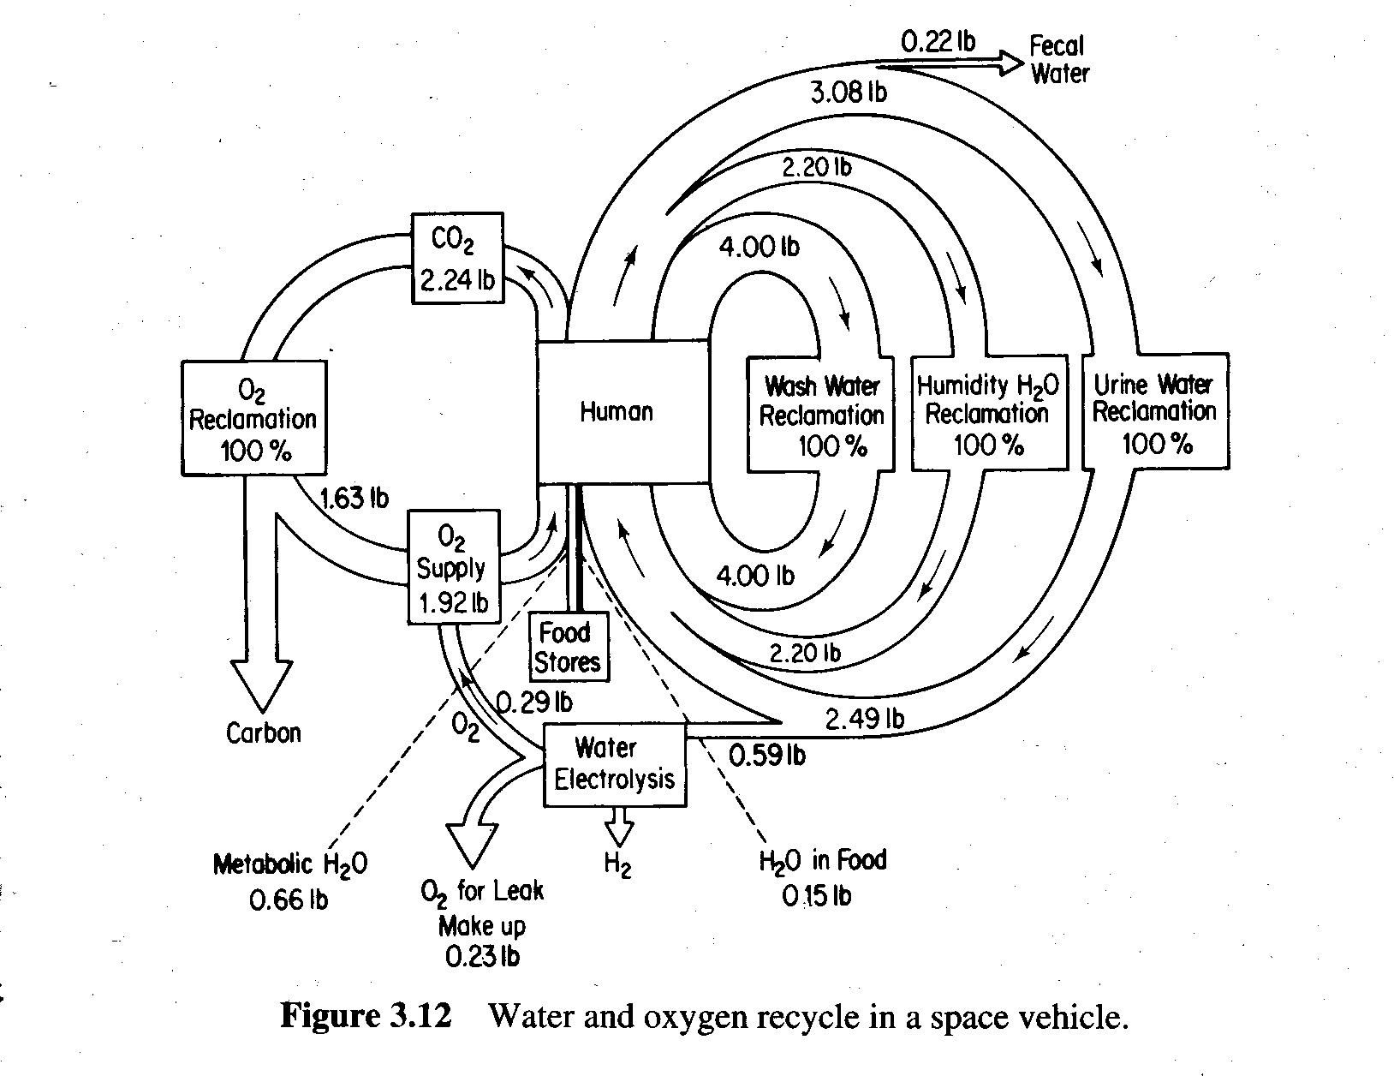

Examples of Graphs and Charts

