Technical Writing Information Sheets
Department of Chemical Engineering
Auburn University, AL 36849
Revision: May 2009- Word 2007 Version

Format for Equations

Equations in technical memorandums should be in the same format as chemical engineering textbooks and journals. The following are the major features and issues to be observed in writing memos:

1. Equations must be entered using an equation editor. In the case of Microsoft Word ®, the Microsoft Equation Editor ® (MEE) should be employed. This can be invoked by selecting Insert / Object / Microsoft Equation 3.0.

2. The equation editor should be employed to enter stand alone equations, such as

$C_{D}=1.328\sqrt{\frac{μ}{Lv_{∞}ρ}}=\frac{1.328}{N_{Re,L}^{1/2}}$ (1)
or to enter inline equations such as $C_{D}=24/Re$ which appear within a sentence.

3. Equations are numbered consecutively, with the reference number appearing inside parenthesis and right-justified on the same line as the equation.

$h_{nat}=2.0{(T_{surface}-T_{ambient})}^{1/3}$ (2) (1)

In order to achieve this spacing with 8.5” x 11” paper with 1” margins, the following procedure is suggested. Note: In the following, inch designations refer to the 6.5 inch region between the margins, not measurements from the left edge. The same right margin applies for the text as well as the equation numbers.
- Set a tab at 3.25” which is a “centered tab”
- Set a tab at 6.5” which is a “right tab”
- Enter the equation as: {Tab}{Equation}{Tab}(Number)
- Once an equation has been entered with this format, copy and paste any previously formatted equation to where you wish a new equation, and then edit the copy to reflect the desired equation and number.

- Equations should appear in the same font and size as the text.
- Note that the MEE will italicize certain characters (see Eq. (2), for example), therefore, one should use that nomenclature and style consistently in the document. One can also change the font styles used in the MEE to not use italics.
- All of the variables (symbols) in an equation need to have been previously defined or defined immediately after the equation is presented. As an example:

“When there is no spray, the natural convection heat transfer coefficient h_{nat} (W/m²K) is given by

$h_{nat}=2.0{(T_{surface}-T_{ambient})}^{1/3}$ (3)

where T_{surface} and T_{ambient} are the slab and ambient temperatures (K), respectively.”

- Equations should be referenced within the text as "Eq. (4)" or "Eqs. (2) and (3)" or "Eqs. (1-6)." For example: "From Eq. (1), it can be seen that the drag coefficient C_{D} approaches infinite for very short plate lengths ().” When the reference to an equation begins a sentence, it should be spelled out:

"Equation (1) is the mathematical model of a …."

- Standard nomenclature and symbols should be used whenever possible. Formulas and equations should be created to clearly distinguish capital letters from lowercase letters. Care should be taken to avoid confusion between the lowercase letter “l” ("ell") and the number “1” (one), or between zero (0) and the upper and lowercase letters “O” and “o.” All subscripts, superscripts, Greek letters, and symbols should be clear (sufficiently large). Double subscripts and two-level subscripts should be avoided, if possible.

- In some cases, a report may require a nomenclature section, which lists all variables and constants in alphabetical order (capital letters first, followed by lowercase letters), followed by Greek symbols, with subscripts and superscripts last, identified with headings. Definitions of each quantity and typical units should appear in the nomenclature list.

- Engineering equations are composed of symbols, not words. It is not appropriate to write “word equations” such as:

weight gain = height ^{1.51} + age ^{0.61}

A symbol is a single letter or character from a defined set which may be modified by using subscripts or superscripts. The subscripts and superscripts may be single letters or characters or may be abbreviations or full words. Generally brevity is preferred. Certain symbols break this convention such as the use of the first two letters of a person’s last name to represent a dimensionless quantity, Re, Pr, Sc, etc.

- It is never appropriate to use any of the following when writing equations:

Symbol | Meaning
x | For multiplication
* | For multiplication
^ | Raining to a power
** | Raising to a power
E | Power of ten

The following are incorrect:

A = π x r^2
V = 4/3 * π**3
g = 32.174 ft s^(-1)

12. Comments about Numbers

- When numerical values in decimal format with units are to be reported in the text, use the following style: 0.123 kJ/(kg K).

- Values less than one are preceded by a leading zero: 0.123 rather than .123

  - When numerical values in scientific format are to be reported, use the following style: 2.345 x 10⁶ Btu/(ft² h). The notation 2.345E6 is not employed.
  - Note: There is a space before and after the “x”
  - Note: There is a space between the numerical value and the units

- Some authors employ a strict interpretation of SI rules and require that exponents be powers of 3. In general, in chemical engineering this in not observed, and instead, one digit appears before the decimal point. For example, use 3.456 x 10⁴ rather than 34.56 x 10³

Figure 1 shows a typical page from a chemical engineering textbook (Geankopolis, 1993) and illustrates many of these features:

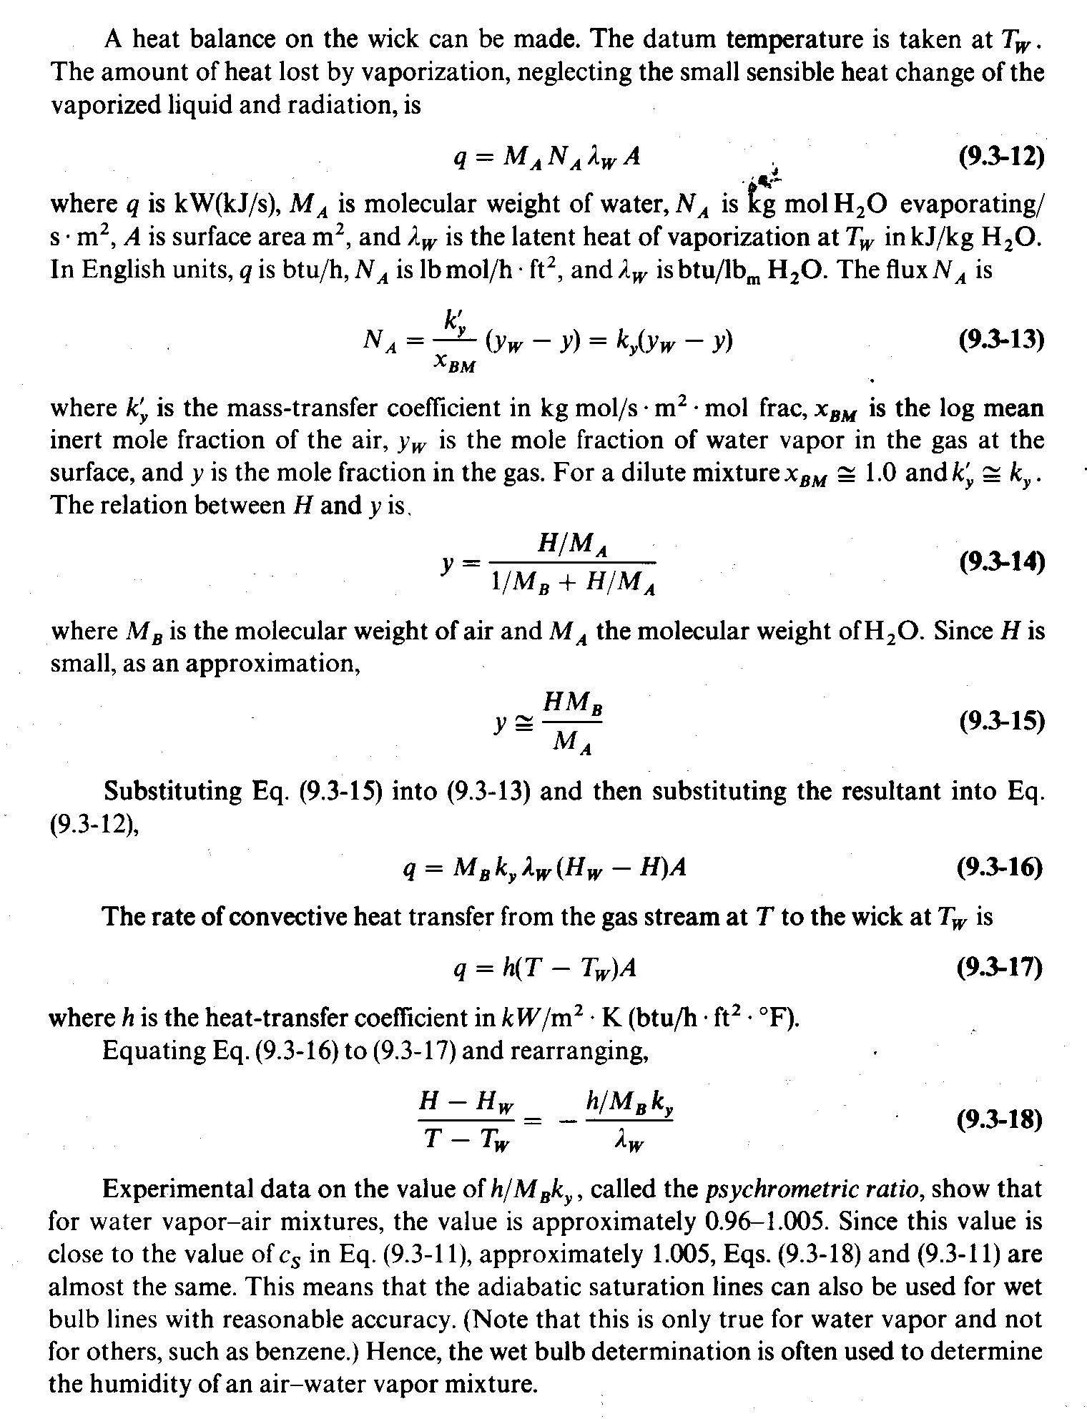
Figure 1 – Examples of equation usage in a typical chemical engineering textbook.

